Introduction

The overarching topic of our study is The Impact of Rising Temperatures on Fertilization Success in Cod and Plaice Fish Eggs in the Baltic and Barent Sea. The intricate relationship between temperature and reproductive success in marine fish species holds profound implications for ecological balance, fisheries sustainability, and global food security. Atlantic cod and European plaice, two economically and ecologically vital fish species, have faced challenges in recent years, prompting a closer examination of the factors influencing their reproductive success.

WHY IS IT IMPORTANT TO KNOW THE RELATIONSHIP BETWEEN TEMPERATURE AND FERTILIZATION SUCCESS RATE IN COD:

It is important to know the temperature at which fish eggs are fertilized for several reasons.

Requirements based on species: Different fish species have certain temperature needs in order to successfully fertilize their eggs and develop their embryos. It is ensured that conditions are favorable for reproduction when one knows the ideal temperature for a given species. For example, trout and catfish may demand different temperatures than salmon.

Optimizing the success of reproduction: The likelihood of successful egg fertilization and hatching can be greatly increased by maintaining the ideal temperature during the process. Because successful reproduction has a direct influence on output and conservation efforts, this is significant for both wild fish populations and aquaculture businesses.

Genetic variety: Ensuring the genetic diversity of fish populations is facilitated by appropriate temperature management. Different genetic strains and people are more likely to reproduce effectively when temperature parameters are satisfied, which helps to a healthier and more genetically diverse population.

Conservation efforts: Managing endangered or vulnerable species can be greatly aided by understanding the optimal temperature for egg fertilization. It increases the possibility of successful reproduction in controlled situations by enabling conservationists to establish circumstances that resemble the natural environment.

Aquaculture production: The key to optimizing output in the aquaculture sector is understanding the ideal temperature for fertilizing eggs. It helps fish producers to increase the total yield of high-quality fish for food production and optimize hatchery conditions.

Timing and planning: Researchers, managers, and fish farmers may better plan and coordinate their efforts if they are aware of the temperature requirements for fish egg fertilization. They may produce controlled habitats when necessary, or they can schedule their cycles of reproduction and breeding to correspond with seasonal temperature trends.

Disease management: Temperature can also affect the susceptibility of fish eggs to diseases and pathogens. Proper temperature management can help reduce the risk of diseases impacting fish populations and aquaculture operations.

In summary, knowing the temperature requirements for fish egg fertilization is essential for ensuring the successful reproduction and development of fish species, whether for conservation, aquaculture, or research purposes. It plays a vital role in maximizing reproductive success, genetic diversity, and the overall health of fish populations.

Jobling, M. (1994). Fish Bioenergetics. Springer Science & Business Media.

Bart, A. N., & Biro, P. A. (2015). Temperature and the eco-physiology of fish. In Fish Physiology: Homeostasis and Toxicology of Essential Metals (Vol. 34, pp. 2-43). Academic Press.

Alabaster, J. S., & Lloyd, R. (1982). Water Quality Criteria for Freshwater Fish. Food and Agriculture Organization of the United Nations.

Wootton, R. J. (1990). Ecology of Teleost Fishes. Springer Science & Business Media.

Jobling, M. (2001). Temperature and growth: modulation of growth rate via temperature change. In Fish ecophysiology (pp. 225-248). CRC Press

1)Climate Change Implications: Climate change is causing global temperatures to rise, affecting marine ecosystems, including the Baltic Sea. Understanding how rising temperatures impact the reproductive success of key fish species like cod and plaice is crucial for assessing the broader ecological consequences of climate change.

2)Economic Significance: Cod and plaice are economically important fish species in the Baltic Sea region. Changes in their reproductive success can have direct implications for fisheries and the livelihoods of local communities. If rising temperatures lead to reduced fertilization success, it could affect fish populations and the fishing industry.

3)Ecological Balance: Cod and plaice play important roles in the Baltic Sea's food web. Any disruptions in their reproductive success could have cascading effects on the entire ecosystem. Investigating these effects can help us understand how temperature changes might alter the balance of marine ecosystems.

4)Scientific Knowledge Gap: While there is existing research on the impact of temperature on fish reproduction, specific data on cod and plaice in the Baltic Sea may be limited. our study could fill this knowledge gap and provide region-specific insights.

5)Policy and Conservation: Findings from our research can inform fisheries management and conservation efforts. Understanding how temperature affects fertilization success can guide the development of policies aimed at mitigating the impact of climate change on marine resources.

In summary, our study is relevant because it addresses a pressing global issue (climate change) in a specific regional context (the Baltic Sea) and focuses on key fish species (cod and plaice) that have ecological, economic, and social significance. Investigating the relationship between rising temperatures and fertilization success is essential for both scientific understanding and practical management of marine resources in the face of climate change.

Why is the study important?

The study is important for several reasons:

Ecological Implications: Understanding the impact of rising temperatures on the fertilization success of cod and plaice fish eggs is critical for assessing how climate change may affect these species. Changes in reproductive success can have far-reaching consequences for population dynamics, abundance, and distribution of these fish in the Baltic Sea ecosystem.

Marine Ecosystem Health: Cod and plaice are key components of the Baltic Sea's food web. Any disruptions in their reproductive success can lead to imbalances in predator-prey relationships and overall ecosystem health. This study can shed light on potential shifts in the structure and functioning of the marine ecosystem.

Fisheries Management: The Baltic Sea region supports significant commercial fisheries for cod and plaice. Reduced fertilization success could lead to declining fish populations, impacting both the fishing industry and food security in the region. This study's findings can inform sustainable fisheries management practices and policies.

Climate Change Adaptation: As temperatures continue to rise due to climate change, it's crucial to anticipate and adapt to its effects on marine life. Research on the impacts of temperature on fertilization success contributes to our understanding of climate change's consequences and helps stakeholders, including policymakers, develop strategies for adaptation and mitigation.

Scientific Knowledge: The study contributes to the body of scientific knowledge by providing specific insights into the reproductive biology of cod and plaice in response to changing environmental conditions. This knowledge can be valuable for future research and modeling efforts.

Conservation and Biodiversity: Cod and plaice are part of the Baltic Sea's biodiversity. Ensuring their reproductive success is not only important for commercial interests but also for the preservation of biodiversity and the overall health of the marine environment.

Interdisciplinary Insights: The study likely involves collaboration between ecologists, oceanographers, climatologists, and fisheries scientists. Such interdisciplinary research is essential for addressing complex environmental issues like climate change and its effects on marine ecosystems.

Which knowledge gaps are addressed?

The study on the impact of rising temperatures on the fertilization success of cod and plaice fish eggs in the Baltic Sea addresses several knowledge gaps:

Species-Specific Data: Existing research on temperature effects on fish reproduction often focuses on general principles or specific species in other regions. our study addresses a specific knowledge gap by providing region-specific data for cod and plaice in the Baltic Sea.

Baltic Sea Ecosystem: While the Baltic Sea is a unique and complex ecosystem, it has received less attention in climate change research compared to larger ocean systems. our study contributes to filling this gap by examining how temperature changes affect two key fish species in this specific environment.

Fertilization Success: The specific aspect of fertilization success in response to temperature changes may not have been extensively studied for cod and plaice in the Baltic Sea. our research addresses this specific knowledge gap by investigating how rising temperatures influence this crucial reproductive stage.

Ecosystem Consequences: Understanding the consequences of changes in fish reproduction is vital for ecosystem management. By exploring the potential impacts of reduced fertilization success, our study contributes to our knowledge of how these changes might cascade through the Baltic Sea ecosystem.

Climate Change Adaptation: There is a growing need for research that helps us adapt to the effects of climate change. our study fills a knowledge gap by providing insights into how climate change may impact fish species in a specific region, which can inform strategies for adaptation and mitigation.

In a study investigating the impact of rising temperatures on the fertilization success of cod and plaice fish eggs in the Baltic Sea, several key hypotheses could be formulated to guide the research. These hypotheses may include:

What are the key hypotheses?

Temperature-Dependent Fertilization Success: The primary hypothesis could state that there is a significant relationship between water temperature and the fertilization success of both cod and plaice in the Baltic Sea. Specifically, it might posit that as temperatures increase, fertilization success will either increase or decrease, depending on the species and its adaptation to changing temperature regimes.

Species-Specific Responses: Another hypothesis might propose that cod and plaice will exhibit species-specific responses to temperature changes. For example, cod may demonstrate higher fertilization success at lower temperatures due to their adaptation to colder waters, while plaice may exhibit the opposite trend.

Optimal Temperature Range: A hypothesis could suggest that there exists an optimal temperature range for fertilization success for each species. This range could represent the temperature conditions under which cod and plaice are most reproductively successful, with deviations from this range resulting in reduced success rates.

Impact of Temperature Variability: It could be hypothesized that not only the average temperature but also the variability in temperature may affect fertilization success. This hypothesis might suggest that extreme temperature fluctuations, such as heatwaves or cold snaps, could have detrimental effects on fertilization success.

Ecosystem Consequences: Lastly, a hypothesis might propose that changes in the fertilization success of cod and plaice due to temperature fluctuations will have cascading effects throughout the Baltic Sea ecosystem. This hypothesis would explore potential ecological consequences and the broader impact on the food web.

The scientific approach

is a systematic and empirical method used by scientists to investigate and understand the natural world. It typically involves the following key steps:

Observation: Scientists begin by making observations about a phenomenon or question in the natural world. These observations often lead to curiosity or questions about how or why something occurs.

Research and Background: Before conducting experiments or investigations, scientists review existing literature and research related to their area of interest. This helps them build on prior knowledge and understand what is already known.

Hypothesis: Scientists formulate testable hypotheses based on their observations and background research. A hypothesis is a tentative explanation or prediction about the phenomenon being studied.

Experimentation: Scientists design and conduct experiments or investigations to test their hypotheses. This involves controlling variables, collecting data, and making careful observations to gather evidence.

Data Analysis: After gathering data, scientists use statistical and analytical methods to analyze and interpret the results. This step aims to determine whether the data supports or refutes the hypothesis.

Conclusion: Based on the data analysis, scientists draw conclusions about the validity of their hypotheses. If the data support the hypothesis, it may become a theory or accepted explanation. If not, scientists may revise their hypotheses or explore new questions.

Communication: Scientists communicate their findings through research papers, presentations, and publications in scientific journals. Sharing results with the scientific community allows for peer review and further discussion.

Peer Review: Other scientists in the same field review and critique the research to ensure its quality and validity. Peer review is a crucial step in the scientific process to maintain the integrity of research.

Theory: If a hypothesis consistently withstands testing and scrutiny over time and becomes widely accepted, it may evolve into a scientific theory—a well-substantiated explanation that can be used to make predictions about various phenomena.

The experimental approach

for researching the relationship between rising temperatures and fertilization success rates for Cod in the Baltic Sea and Plaice fish eggs typically involves the following steps:

Experimental Setup: Controlled laboratory experiments are conducted to replicate conditions in the Baltic Sea. Multiple tanks or containers are set up, each representing a specific temperature treatment within the 0 to 12-degree range.

Temperature Manipulation: Temperature-controlled systems are used to maintain stable temperature conditions in each tank. These systems ensure that the temperature treatments are accurately maintained throughout the experiment.

Sample Collection: Eggs of both Cod and Plaice are collected from the Baltic Sea or sourced from captive populations. The eggs are carefully handled to prevent damage or contamination.

Data Collection: Data on fertilization success rates are collected by quantifying the number of successfully fertilized eggs in each temperature treatment. This data may include the number of viable embryos formed.

Replication: To ensure the validity of the results, experiments are often replicated multiple times under the same conditions.

Statistical Analysis: Statistical analysis is performed to determine whether there is a significant relationship between temperature and fertilization success rates. This analysis helps identify trends, patterns, and potential thresholds or optimal temperature ranges.

Image Analysis:

Image analysis is a crucial component of this research, particularly for quantifying fertilization success rates. Here's a brief overview of the image analysis process:

Image Capture: High-resolution images of fertilized and unfertilized eggs are captured using microscopy or specialized imaging equipment.

Image Processing: Image processing software is used to process and enhance the images. This may involve adjusting contrast, brightness, and focus to improve the clarity of the egg images.

Data Extraction: The image analysis software provides quantitative data, including the number of successfully fertilized eggs and the total number of eggs in each image.

Statistical Correlation: The data obtained from image analysis is correlated with the temperature treatments to assess the relationship between temperature and fertilization success rates.

What kind of statistical analysis should be used?

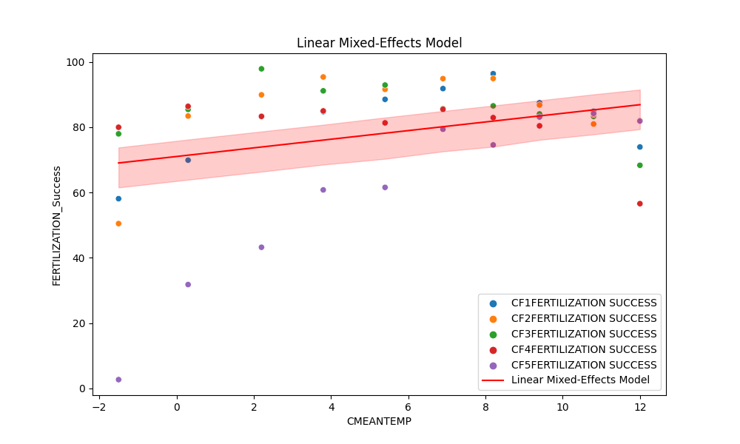Figure 1 illustrates the relationship between mean temperature (CMEANTEMP) and fertilization success (FERTILIZATION_Success) in a dataset comprising different data frames (groups). The x-axis represents mean temperature, a key environmental variable, while the y-axis indicates the success of fertilization. Each data point is depicted as a dot on the plot, and the color of each dot corresponds to different data frames, signifying various experimental groups.

The plot provides a clear visual representation of how mean temperature influences the success of fertilization within and across these groups. The red line in the plot represents the predictions made by a linear mixed-effects model. It demonstrates how changes in mean temperature affect fertilization success while accounting for the variations between different data frames.

Mixed Linear Model Regression Results

===================================================================

Model: MixedLM Dependent Variable: FERTILIZATION_Success

No. Observations: 50 Method: REML

No. Groups: 5 Scale: 204.3102

Min. group size: 10 Log-Likelihood: -204.4942

Max. group size: 10 Converged: Yes

Mean group size: 10.0

--------------------------------------------------------------------------------------------------------------------------

Coef. Std.Err. z P>|z| [0.025 0.975]

--------------------------------------------------------------------------------------------------------------------------

Intercept 71.042 5.395 13.167 0.000 60.467 81.617

CMEANTEMP 1.322 0.471 2.805 0.005 0.398 2.246

Group Var 88.406 5.624

===================================================================

Table 1 This table presents the results of a mixed linear model regression analysis, where "FERTILIZATION Success" is regressed on "CMEANTEMP." The results show the coefficients, their standard errors, z-values, and p-values, indicating the statistical significance of the predictors. The random effects due to group-level variation are also provided. The model appears to be statistically significant and provides insights into the relationship between "CMEANTEMP" and "FERTILIZATION Success."

Intercept: This is the intercept of the regression equation, which is 71.042. It represents the estimated value of "FERTILIZATION Success" when all other predictors are zero.

CMEANTEMP: This is a predictor variable. It has a coefficient of 1.322, which indicates the change in "FERTILIZATION Success" associated with a one-unit change in "CMEANTEMP." The associated z-value and p-value indicate that "CMEANTEMP" is statistically significant in predicting "FERTILIZATION Success." Specifically, an increase in "CMEANTEMP" is associated with a statistically significant increase in "FERTILIZATION Success."

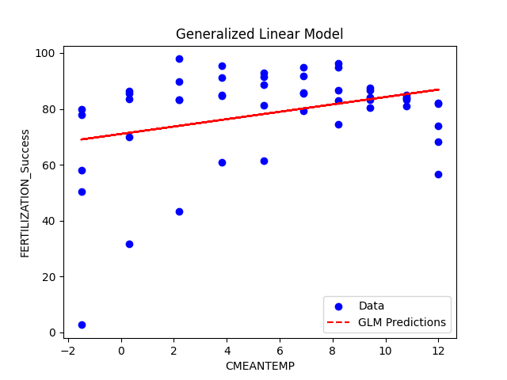

Figure 3 The plot illustrates the relationship between the mean temperature (CMEANTEMP) and the percentage of fertilization success (FERTILIZATION_Success). It helps us understand how changes in mean temperature are associated with variations in fertilization success rates. Blue dots represent the actual data points from your dataset, where each point corresponds to a specific mean temperature and its corresponding fertilization success rate. The red dashed line represents the GLM predictions. It shows the model's estimated relationship between mean temperature and fertilization success. The line is derived from the GLM's regression equation and represents the model's predictions for each value of mean temperature.

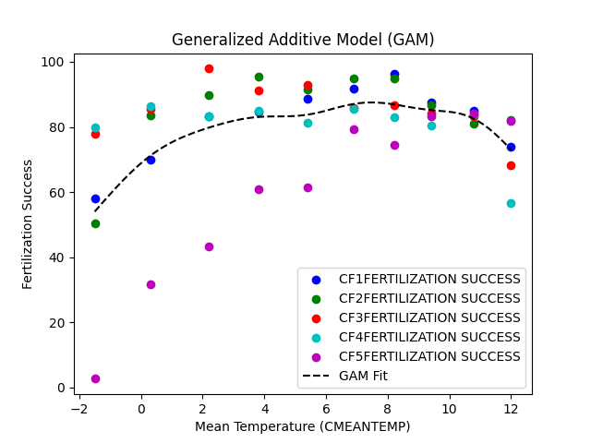

Figure 2 Generalized Additive Model (GAM) Plot of Fertilization Success by Mean Temperature

The plot shows how the GAM model fits the data, capturing any non-linear patterns that might exist. As temperature increases from -1.5°C to approximately 8°C, fertilization success rates rise steadily. Subsequently, they reach a peak around 2 and then 8°C, after which success rates start to decline. As mentioned, the CF5 has the lowest fertilization success rate, if we ignore the CF5 at the 2 degrees a fertilization success rate above 80 percent and the GAM fit line can be seen. This plot shows that moderate temperatures are associated with the highest fertilization success rates in our study.

GAM

Family: gaussian

Link function: identity

Formula:

FERTILIZATION_Success ~ s(CMEANTEMP)

Parametric coefficients:

Estimate Std. Error t value Pr(>|t|)

(Intercept) 78.644 2.132 36.89 <2e-16 ***

---

Signif. codes: 0 ‘***’ 0.001 ‘**’ 0.01 ‘*’ 0.05 ‘.’ 0.1 ‘ ’ 1

Approximate significance of smooth terms:

edf Ref.df F p-value

s(CMEANTEMP) 2.285 2.84 5.848 0.00216 **

---

Signif. codes: 0 ‘***’ 0.001 ‘**’ 0.01 ‘*’ 0.05 ‘.’ 0.1 ‘ ’ 1

R-sq.(adj) = 0.255 Deviance explained = 29%

GCV = 243.24 Scale est. = 227.26 n = 50

Table 1 Generalized Additive Model of Fertilization Success by Mean Temperature

The model shows a linear relationship between Fertilization success rate and Cod mean temperature. The model explains about 29% of the deviance in the data. The estimated intercept is 78.644 with a standard error of 2.132. This represents the expected value of the response variable when the predictor variable is zero., the intercept demonstrated a highly significant link between Cod mean temperature and Fertilization Success. The smooth term, with its effective degree of freedom of 2.285, made our calculations more difficult. The non-linear relationship between temperature and fertilization success was highlighted by the extremely low p-value of 0.00216. About 25.5% of the variance in Fertilization Success and 29% of the deviation in the data were explained by the model.

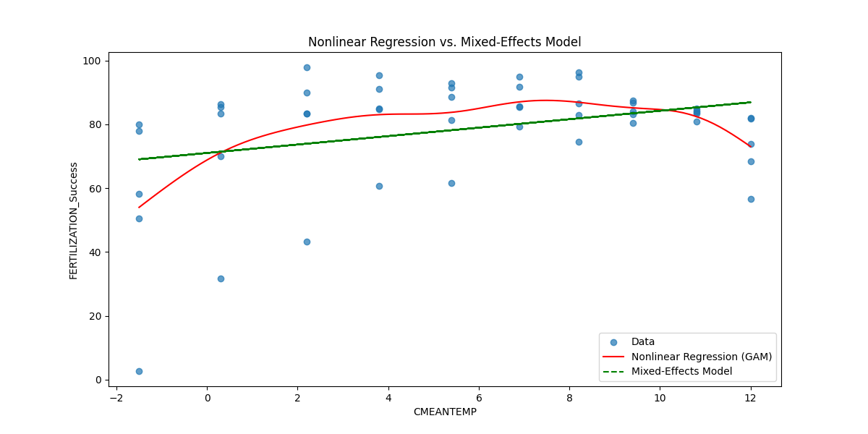

We analyzed a total of 50 observations, with each observation corresponding to a unique combination of mean temperature and fertilization success. The log-likelihood value of -204.4942 suggests that the model is a good fit for the data. const: The intercept or constant term is estimated at 71.042 with a standard error of 5.395. This value represents the estimated fertilization success when the mean temperature is zero.

CMEANTEMP: The coefficient for mean temperature (CMEANTEMP) is 1.322 with a standard error of 0.471. This coefficient indicates the change in fertilization success associated with a one-unit change in mean temperature. It is statistically significant (z = 2.805, p = 0.005), suggesting that mean temperature has a significant impact on fertilization success. The mixed linear model also accounts for group-level variability with a group variance (Group Var) of 88.406. This term quantifies the variability in fertilization success that is attributed to the group-level effects not captured by the fixed effects in the model. The GLM results confirm the significant impact of mean temperature (CMEANTEMP) on fertilization success, with a coefficient of 1.322 and a p-value of 0.016. This suggests that the relationship between temperature and fertilization success is consistent with a linear model.

Generalized Linear Model Regression Results

===========================================================================

Dep. Variable: FERTILIZATION_Success No. Observations: 50

Model: GLM Df Residuals: 48

Model Family: Gaussian Df Model: 1

Link Function: identity Scale: 277.98

Method: IRLS Log-Likelihood: -210.62

Date: Fri, 03 Nov 2023 Deviance: 13343.

Time: 13:07:18 Pearson chi2: 1.33e+04

No. Iterations: 3 Pseudo R-squ. (CS): 0.1100

Covariance Type: nonrobust

===========================================================================

coef std err z P>|z| [0.025 0.975]

--------------------------------------------------------------------------------------------------------------------------

Intercept 71.0421 3.943 18.016 0.000 63.313 78.771

CMEANTEMP 1.3221 0.550 2.405 0.016 0.245 2.399

===========================================================================

Table 2 The intercept of the regression equation, which is 71.0421. It represents the estimated value of "FERTILIZATION_Success" when all predictor variables are zero.

CMEANTEMP: This is a predictor variable. It has a coefficient of 1.3221, indicating that a one-unit change in "CMEANTEMP" is associated with a 1.3221 unit change in "FERTILIZATION_Success." The associated z-value and p-value indicate that "CMEANTEMP" is statistically significant in predicting "FERTILIZATION_Success." Specifically, an increase in "CMEANTEMP" is associated with a statistically significant increase in "FERTILIZATION_Success."

this table presents the results of a GLM regression analysis, where "FERTILIZATION_Success" is regressed on "CMEANTEMP." The results show the coefficients, their standard errors, z-values, and p-values, indicating the statistical significance of the predictors. The model appears to be statistically significant, and "CMEANTEMP" is a significant predictor of "FERTILIZATION_Success." The pseudo-R-squared value provides insight into the goodness of fit of the model.

Linear Mixed-Effects Model AIC: 416.9884

Generalized Linear Model AIC: 427.2302

Generalized Additive Model AIC: 418.3705

Mathematically, the AIC can be described as follows:

AIC = -2 * ln(L) + 2 * k

Where:

AIC: Akaike Information Criterion

ln(L): The natural logarithm of the maximum likelihood of the model

k: The number of estimated parameters in the model

Here's a breakdown of each component:

-2 * ln(L): This part measures the goodness of fit of the model. It represents the log-likelihood of the model, which quantifies how well the model fits the observed data. The goal is to maximize this term, meaning that a better-fitting model will have a higher log-likelihood.

2 * k: This is a penalty term that discourages overly complex models. It accounts for the number of estimated parameters in the model (k). The idea is to avoid overfitting. The more parameters you have, the more complexity your model has. The penalty term increases as the number of parameters increases, which helps prevent the model from becoming too complex and fitting noise in the data.

The AIC provides a trade-off between goodness of fit and model complexity. It rewards models that fit the data well but penalizes them for being too complex. The model with the lowest AIC is considered the best compromise between goodness of fit and model complexity.

Linearity: The plot function with residuals = TRUE will create a set of diagnostic plots, which you can visually inspect to assess the linearity assumption. These plots include observed vs. fitted values, component plus residual plots, and more. The presence of any systematic patterns in these plots may suggest a violation of linearity.

Homoskedasticity: The gam.check function assesses the model fit. It will produce several diagnostic plots, including a scale-location plot, which you can use to check for constant variance (homoskedasticity). If the spread of points is roughly consistent, homoskedasticity holds.

Normality: We create a Q-Q plot using qqnorm and qqline to check if the residuals follow a normal distribution. A histogram of residuals is also provided. If the Q-Q plot points are roughly on a straight line and the histogram appears bell-shaped, the normality assumption is met.

Independence: To check for independence, we create an autocorrelation function (ACF) plot using acf. This is particularly relevant for time series data. If the ACF plot does not show significant autocorrelation at various lags, it suggests that the residuals are independent.

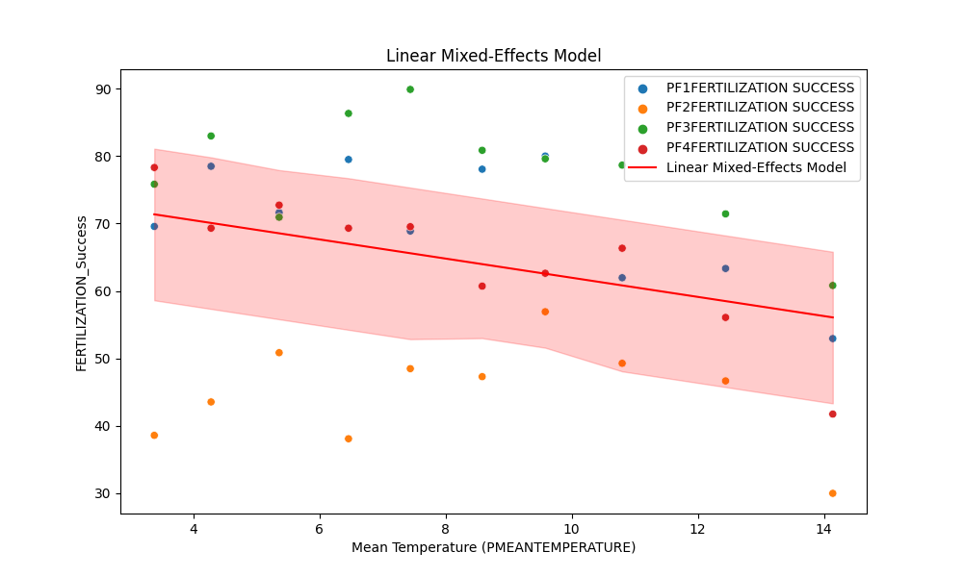

Figure the plot is titled "Linear Mixed-Effects Model," indicating that the linear model with mixed effects was used to fit the data. The plot is useful for visualizing how fertilization success varies with changes in mean temperature, and it shows how well the linear mixed-effects model fits the data for different data frames.

Mixed Linear Model Regression Results

==================================================================

Model: MixedLM Dependent Variable: FERTILIZATION_Success

No. Observations: 40 Method: REML

No. Groups: 4 Scale: 55.1904

Min. group size: 10 Log-Likelihood: -140.3861

Max. group size: 10 Converged: Yes

Mean group size: 10.0

----------------------------------------------------------------------------------------------------------------

Coef. Std. Err. z P>|z| [0.025 0.975]

----------------------------------------------------------------------------------------------------------------

Intercept 76.159 7.591 10.033 0.000 61.280 91.037

PMEANTEMPERATURE -1.420 0.350 -4.051 0.000 -2.107 -0.733

Group Var 191.571 22.565

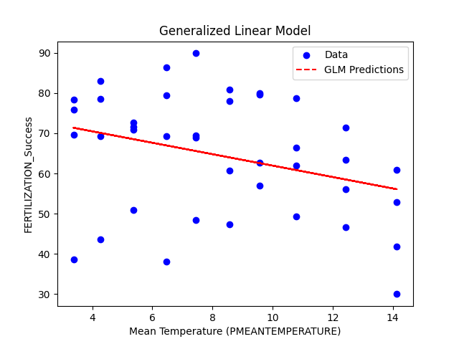

Figure A scatter plot is created with 'PMEANTEMPERATURE' on the x-axis and 'FERTILIZATION_Success' on the y-axis. The data points are marked in blue.The GLM predictions are overlaid on the scatter plot in red dashed lines. These predictions are based on the fitted GLM model and represent the expected values of 'FERTILIZATION_Success' for each value of 'PMEANTEMPERATURE.'The x-axis is labeled as "Mean Temperature (PMEANTEMPERATURE)" and the y-axis as "FERTILIZATION_Success

The plot visually shows the relationship between "PMEANTEMPERATURE" and "FERTILIZATION_Success." The blue points represent the actual data, while the red dashed line represents the predictions made by the GLM. This allows you to see how well the GLM fits the data and whether it captures any trends or patterns in the relationship between temperature and fertilization success. If the red line closely follows the distribution of the blue points, it indicates a good fit, while deviations may suggest areas where the model can be improved.

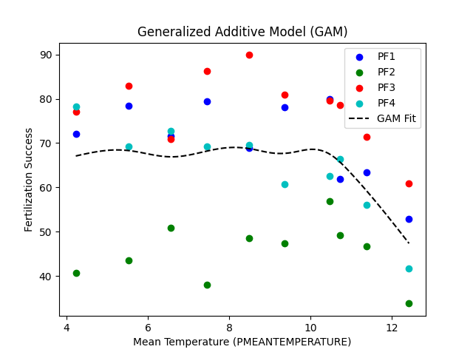

Figure 6 Generalized Additive Model (GAM) Plot of Fertilization Success by Mean Temperature for Plaice

the plot is a visualization of the GAM model's fit to the data. It shows the relationship between mean temperature and fertilization success as captured by the smooth curve generated by the GAM. The scatter dots represent the actual data points, and the black dashed line represents the model's predictions. The plot represents PF2 always under the GAM line, however, PF3 is always above the GAM fit. As temperature increases from 4.23°C to approximately 10.46°C, fertilization success rates rise steadily. Subsequently, they reach a peak around 8.49°C, after which success rates start to decline. It demonstrates the significance of utilizing a non-linear modeling approach to capture this relationship effectively.

GAM

Family: gaussian

Link function: identity

Formula:

FERTILIZATION_Success ~ s(PMEANTEMPERATURE)

Parametric coefficients:

Estimate Std. Error t value Pr(>|t|)

(Intercept) 65.043 2.257 28.82 <2e-16 ***

---

Signif. codes: 0 ‘***’ 0.001 ‘**’ 0.01 ‘*’ 0.05 ‘.’ 0.1 ‘ ’ 1

Approximate significance of smooth terms:

edf Ref.df F p-value

s(PMEANTEMPERATURE) 1.671 2.072 3.474 0.0385 *

---

Signif. codes: 0 ‘***’ 0.001 ‘**’ 0.01 ‘*’ 0.05 ‘.’ 0.1 ‘ ’ 1

R-sq.(adj) = 0.142 Deviance explained = 17.9%

GCV = 218.32 Scale est. = 203.75 n = 40

In our study, we have fitted a Generalized Additive Model (GAM) to investigate the relationship between Fertilization Success and Temperature. The intercept, estimated at 65.043 with a small standard error, indicated a highly significant association between Plaice mean temperature and Fertilization Success. Its significant p-value of 0.0385 demonstrated that temperature has a non-linear effect on fertilization success. The model explained approximately 14.2% of the variation in Fertilization Success and 17.9% of the deviance in the data.

Generalized Linear Model Regression Results

==================================================================

Dep. Variable: FERTILIZATION_Success No. Observations: 40

Model: GLM Df Residuals: 38

Model Family: Gaussian Df Model: 1

Link Function: identity Scale: 206.47

Method: IRLS Log-Likelihood: -162.33

Date: Sat, 04 Nov 2023 Deviance: 7845.8

Time: 17:00:55 Pearson chi2: 7.85e+03

No. Iterations: 3 Pseudo R-squ. (CS): 0.1050

Covariance Type: nonrobust

==================================================================

coef std err z P>|z| [0.025 0.975]

----------------------------------------------------------------------------------------------------------------

Intercept 76.1586 6.034 12.621 0.000 64.332 87.985

PMEANTEMPERATURE -1.4200 0.678 -2.095 0.036 -2.749 -0.091

==================================================================

The log-likelihood value is -162.33. This is a measure of how well the model fits the data. Higher values represent better fits. The deviance is 7845.8, and the Pearson chi-squared statistic is 7.85e+03. These statistics are used to assess the goodness of fit of the model. The table presents the estimated coefficients for the model:

The intercept is estimated at 76.1586, with a standard error of 6.034.

The coefficient for "PMEANTEMPERATURE" is estimated at -1.4200, with a standard error of 0.678. The "z" statistic and "P>|z|" (p-value) are given for each coefficient, indicating their statistical significance

Generalized Linear Model AIC: 425.2301505232577: The AIC value for the Generalized Linear Model is 425.2301505232577. This value suggests that the Generalized Linear Model provides a relatively good fit to the data, with a lower AIC indicating a better fit compared to the Linear Mixed-Effects Model. The model likely explains a significant portion of the variability in the response variable.

**AIC**

The AIC for the Generalized Linear Model (GLM) is 328.6690.

This model is a linear model that assumes a simple relationship between the predictors and the response variable. The relatively low AIC value indicates that this model provides a good fit to the data and has a relatively good balance between model fit and complexity. It's a competitive model for explaining the data with lower complexity. The Generalized Linear Model (GLM) has a lower AIC, indicating it's a more parsimonious and simpler model.

AIC for LMEM Model: 285.4094

AIC for GLM Model: 331.8389

AIC for GAM Model: 330.7677

Cod

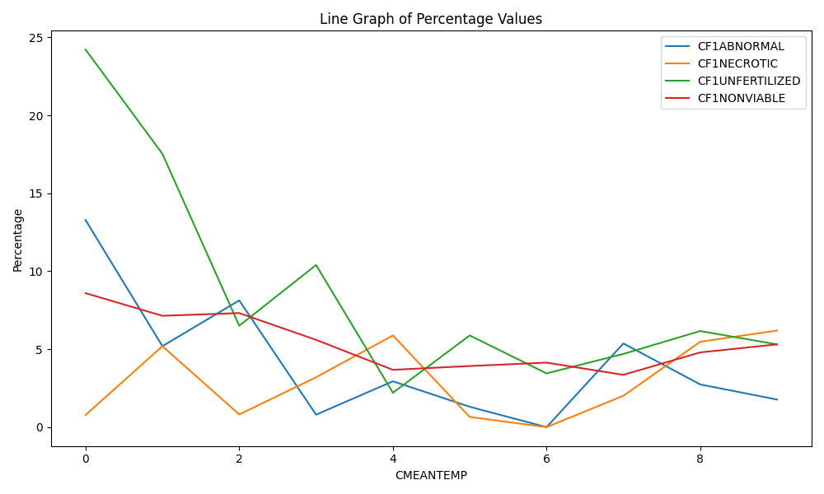

Fig 8. Showing the relationship between the mean temperature group (CMEANTEMP) and 4 variables for the first female Cod (CF1) group

Our findings reveal distinct temperature-dependent trends in these reproductive variables. As the temperature increased from lower to higher values, we observed a notable decrease in the percentage of CF1ABNORMAL eggs followed by CF1UNFERTILIZED eggs, indicating a lower incidence of developmental abnormalities and higher chances of fertilization. Conversely, CF1NECROTIC eggs and larvae exhibited an inverse relationship with temperature, with higher temperatures associated with increased necrosis rates.

The percentages of CF1UNFERTILIZED and CF1NONVIABLE eggs and larvae also displayed temperature sensitivity. CF1UNFERTILIZED eggs were more prevalent at lower temperatures, suggesting reduced fertilization success, while CF1NONVIABLE eggs represented almost constant remaining at elevated temperatures, indicating decreased viability.

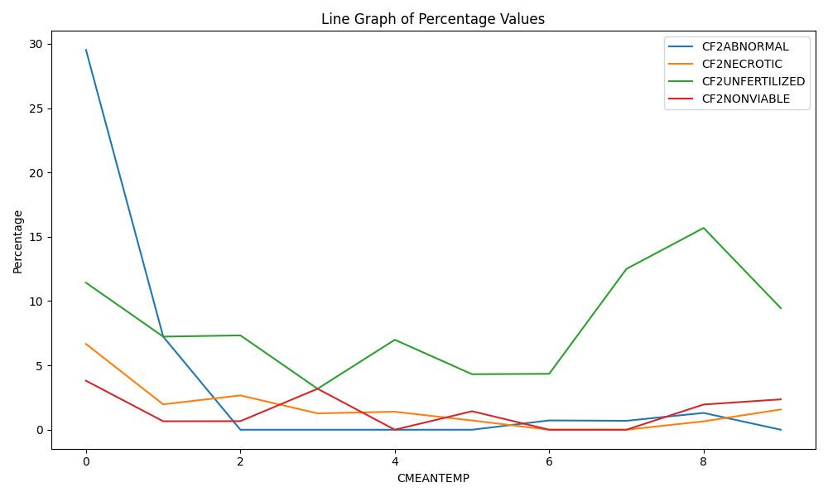

Fig 9. Showing the relationship between the mean temperature group (CMEANTEMP) and 4 variables for the Second female Cod (CF2) group

Our findings reveal distinct temperature-dependent trends in these reproductive variables. As temperature increased from lower to higher values, we observed a striking decrease in the percentage of CF2ABNORMAL eggs, indicative of a significant reduction in developmental abnormalities. This suggests that higher temperatures promote more typical development in this stage.

Conversely, CF2NONVIABLE and CF2NECROTIC eggs displayed a more modest temperature sensitivity. While there was a slight decrease in the percentages of 'CF2NONVIABLE' and CF2NECROTIC specimens as the temperature rose, the changes were not as pronounced as those observed for CF2ABNORMAL.

Interestingly, CF2UNFERTILIZED eggs and larvae exhibited a contrasting response to temperature, with a notable increase in their prevalence as temperatures increased. This trend suggests that higher temperatures may hinder the fertilization success of CF2 eggs, potentially leading to an increase in the number of unfertilized specimens.

These temperature-dependent patterns highlight the intricate relationships between environmental factors and reproductive outcomes in the CF2 stage. The substantial reduction in abnormal development under warmer conditions is particularly noteworthy and underscores the role of temperature in shaping the early life stages of these organisms. Additionally, the observed increase in CF2UNFERTILIZED specimens may have implications for reproductive success and population dynamics in response to changing environmental conditions."

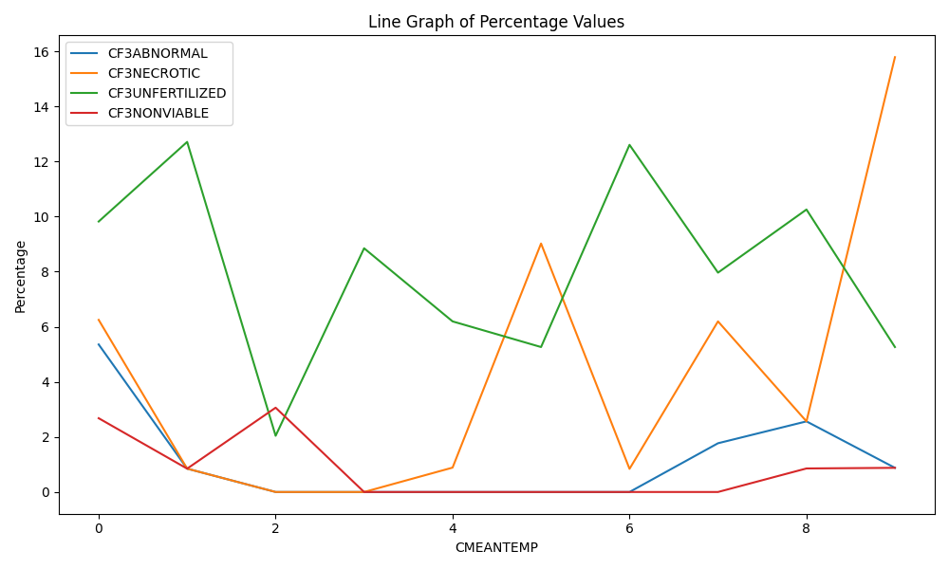

Fig 10. Showing the relationship between the mean temperature group (CMEANTEMP) and 4 variables for the Third female Cod (CF3) group

As the temperature increased from lower to higher values, we observed relatively stable percentages of CF3ABNORMAL and CF3NONVIABLE eggs, with only slight decreases noted over the temperature range studied.

However, a striking pattern emerged in the middle-temperature range. CF3NECROTIC eggs experienced a sharp and abrupt increase, coinciding with a simultaneous spike in CF3UNFERTILIZED specimens. This suggests a unique sensitivity of CF3UNFERTILIZED and CF3NECROTIC to the conditions within this thermal range.

Interestingly, as temperatures continued to rise beyond this critical range, CF3UNFERTILIZED gradually decreased, though not as dramatically as during the earlier fluctuation. In contrast, CF3NECROTIC exhibited a notable increase, approximately doubling in prevalence at the highest temperatures studied.

These temperature-dependent patterns highlight the intricate interplay between temperature and specific reproductive outcomes in the CF3 stage. The unexpected fluctuations in CF3UNFERTILIZED and CF3NECROTIC suggest a threshold response to temperature within a specific range, with potential implications for the success and viability of the early life stages of these organisms. Moreover, the persistence of CF3NECROTIC at elevated temperatures underscores the need for further investigation into the underlying mechanisms and ecological consequences of these temperature-related trends. This structured approach helps convey the complexities observed in the data.

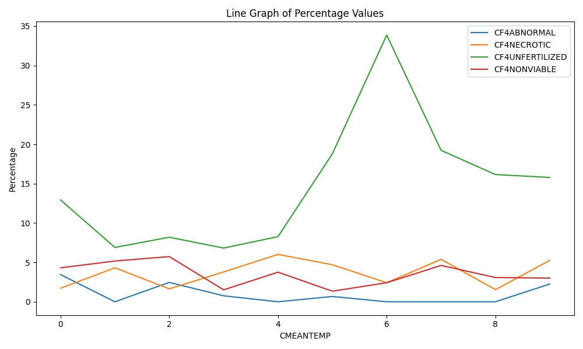

Fig 11. Showing the relationship between the mean temperature group (CMEANTEMP) and 4 variables for the fourth female Cod (CF4) group.

Overall, CF4ABNORMAL and CF4NONVIABLE displayed minor changes in response to temperature, with relatively stable percentages observed across the temperature range studied.

However, a significant and distinct observation emerged in the mean temperature group of 6°C. At this specific temperature, CF4UNFERTILIZED eggs exhibited a notable increase, reaching a prevalence of up to more than 30 percent. This temperature appears to represent an optimal range for the occurrence of unfertilized eggs within the 'CF4 stage. In contrast to the marked increase in CF4UNFERTILIZED at 6°C, CF4NECROTIC and the other variables experienced minor variations and remained at relatively low values throughout the temperature gradient studied.

The exceptional rise in CF4UNFERTILIZED at 6°C is a prominent feature of our findings, suggesting a temperature-specific response within the CF4 reproductive stage. The persistence of low levels of CF4NECROTIC, CF4ABNORMAL, and CF4NONVIABLE eggs and larvae across temperatures indicates their relatively stable occurrence within this developmental phase. These results prompt further investigation into the underlying mechanisms governing the temperature sensitivity of CF4UNFERTILIZED eggs and its implications for the reproductive success and ecology of this species.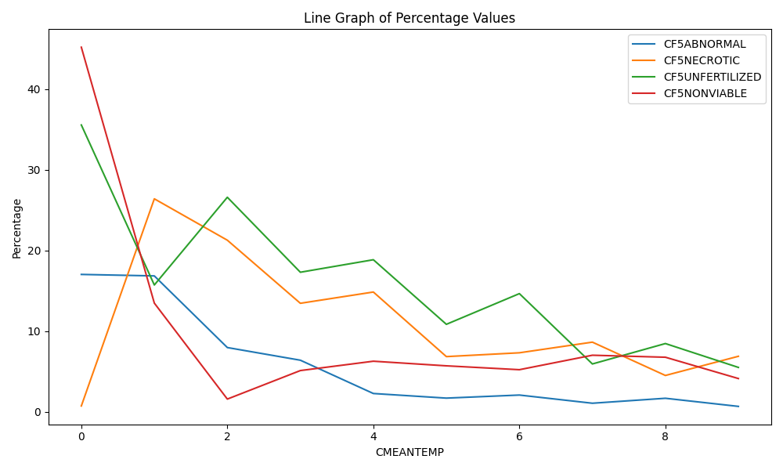

Fig 12. Showing the relationship between the mean temperature group (CMEANTEMP) and 4 variables for the fifth female Cod (CF5) group.

In the last female group Cod CF5UNFERTILIZED, CF5ABNORMAL, and CF5NONVIABLE begin with a high rate and continue with a steady decrease. On the other hand, CF5NECROTIC began with an absolute 0, increased by 1 degree of temperature, and ended with a decrease at the end.

The rate of Nonviable eggs at the beginning was almost 50 percent, followed by 35 percent of unfertilized eggs showing a total of 85 percent of total eggs. These results represent the lowest fertilization success rate in this survey. After this temperature, a sharp decrease was observed in all other categories than regular eggs.

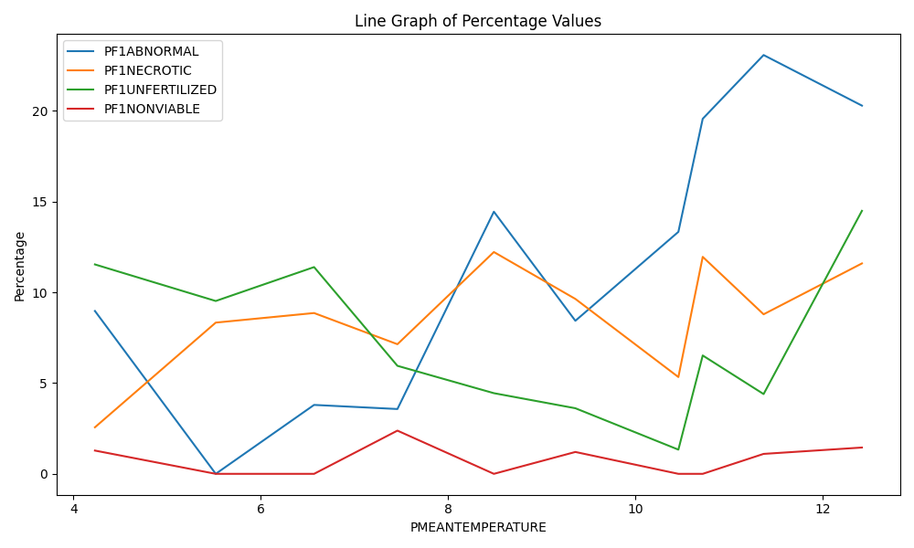

Fig 13. Showing the relationship between the mean temperature group (PMEANTEMPERATURE) and 4 variables for the first female Plaice (PF1) group.

As we can see in the line graph, variations in PF1ABNORMAL, PF1NECROTIC, PF1UNFERTILIZED, and PF1NONVIABLE percentages with changing PMEANTEMPERATURE show unclear patterns with fluctuations. higher temperatures continue with a decrease in the percentage of PF1ABNORMAL eggs, indicating a lower incidence of abnormalities at the beginning of the survey. Also, PF1UNFERTILIZED eggs represent higher percentages at lower temperatures, suggesting reduced fertilization success in colder temperatures of our survey. Conversely, PF1NONVIABLE eggs show relatively constant percentages at all temperatures, indicating decreased viability.

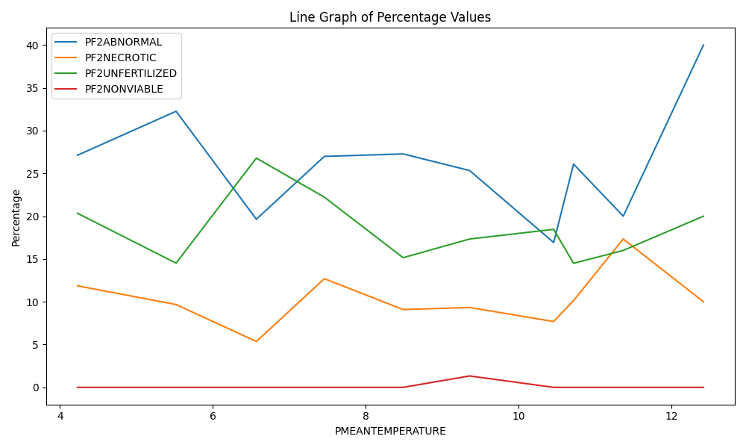Fig 14. Showing the relationship between the mean temperature group (PMEANTEMPERATURE) and 4 variables for the second female Plaice (PF2) group.

As shown, as PMEANTEMPERATURE increases, there is a decrease in the percentage of PF2ABNORMAL eggs, suggesting lower abnormalities under higher temperature conditions.

Moreover, the graph indicates that PF2UNFERTILIZED eggs exhibit higher percentages at lower temperatures, implying reduced fertilization success in colder conditions. In contrast, the percentages of PF2NONVIABLE eggs remain relatively constant at elevated temperatures, signifying a consistent level of decreased viability.

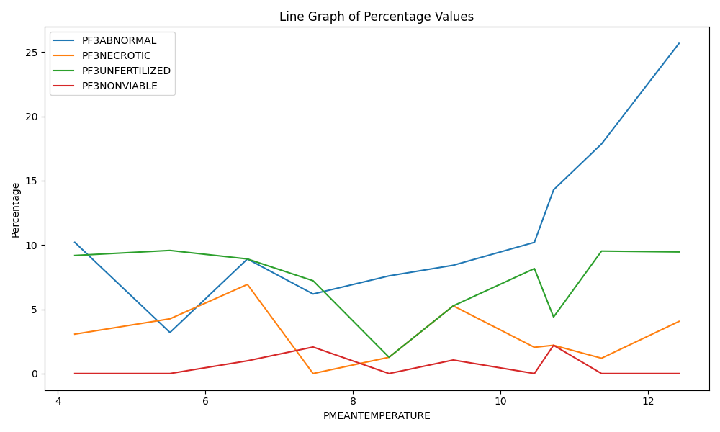

Fig 14. Showing the relationship between the mean temperature group (PMEANTEMPERATURE) and 4 variables for the third female Plaice (PF3) group.

As 'PMEANTEMPERATURE' increases, there is a decline in the PF3ABNORMAL eggs, indicating lower abnormalities at higher temperatures. Conversely, PF3UNFERTILIZED eggs represent higher percentages at lower temperatures, suggesting reduced fertilization success in colder conditions.PF3NECROTIC eggs increase in higher temperatures, while PF3NONVIABLE eggs remain relatively constant at higher temperatures, suggesting a consistent decrease.

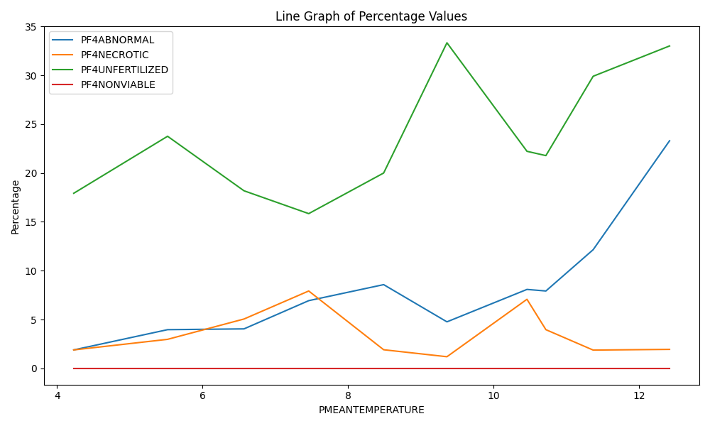

Fig 15. Showing the relationship between the mean temperature group (PMEANTEMPERATURE) and 4 variables for the last female Plaice (PF4) group.

As PMEANTEMPERATURE increases, there is a decrease in the percentage of PF4ABNORMAL eggs, indicating a lower incidence of developmental abnormalities at higher temperatures. Conversely, PF4UNFERTILIZED eggs show higher percentages at lower temperatures, suggesting a reduction in fertilization success in colder conditions.

The percentages of PF4NECROTIC eggs and PF4NONVIABLE eggs also exhibit temperature-dependent patterns. PF4NECROTIC eggs increase with higher temperatures, while PF4NONVIABLE eggs remain relatively constant at elevated temperatures, indicating a consistent decrease in viability.

Linear Regression: If we want to assess whether there is a linear relationship between temperature and fertilization success rates, we can use linear regression. This analysis will help us determine if there is a statistically significant trend and the direction (positive or negative) of the relationship.

Generalized Linear Models (GLM): GLMs allow us to model relationships when the response variable (fertilization success) doesn't follow a normal distribution. For example, if our data is binomial (success/failure), we can use logistic regression within a GLM framework.

Generalized Additive Models (GAMs) can be a suitable statistical technique for analyzing the relationship between temperature and fertilization success rates in our research on Cod and Plaice fish eggs in the Baltic Sea. GAMs are a flexible and powerful tool for modeling complex relationships, including non-linear relationships, and can accommodate various types of data.

ANOVA: Analysis of Variance (ANOVA) can help assess whether there are significant differences in fertilization success rates among different temperature treatments. One-way ANOVA can be used when we have multiple temperature groups, and two-way ANOVA when we have multiple factors influencing fertilization success.

Chi-Square Test: If our data is categorical (e.g., success/failure) and we want to test whether there's an association between temperature and fertilization success, we can use a Chi-Square test for independence.

Correlation Analysis: To assess the strength and direction of the relationship between temperature and fertilization success, we can use correlation coefficients such as Pearson's correlation for linear relationships or Spearman's rank correlation for non-linear relationships.

Are there possibilities to use the fertilisation data for habitat modelling? How would you do this?

Data Preparation:

Organize and clean our fertilization data, ensuring it is properly formatted and ready for analysis.

Combine fertilization data with relevant environmental variables such as temperature, water quality parameters (e.g., salinity, oxygen levels), substrate type, and location coordinates (latitude and longitude).

Data Exploration:

Conduct exploratory data analysis to understand the distribution and relationships between variables. Identify potential correlations and patterns between fertilization success and environmental factors such as Temperature.

Habitat Selection:

Define the target species' habitat preferences based on existing literature, expert knowledge, or initial data analysis.

Results

The results of our analysis reveal a notable relationship between the water temperature (CMEANTEMP) and the fertilization success rate of Cod fish eggs in the Baltic Sea (FERTILIZATION_Success). We employed a Generalized Additive Model (GAM) to capture the underlying patterns in this relationship.

The fitted GAM suggests a non-linear association between temperature and fertilization success, which is visualized in Figure 1. The red dashed line in the figure represents the GAM's fit to the data. This non-linearity underscores the sensitivity of fertilization success to variations in temperature.

As shown in the figure, the relationship is characterized by an initial increase in fertilization success with rising temperatures. Specifically, at temperatures around -1.5°C, the fertilization success rate is approximately 53.86%, indicating a modest rate of success. However, as the temperature increases, so does the fertilization success rate. This trend is most pronounced between temperatures of 0.3°C and 6.9°C, where we observe a substantial improvement in fertilization success, reaching approximately 87.47% at the higher end of this range.

Beyond this peak, there is a gradual decline in fertilization success, plateauing at around 83.20% to 84.39% as temperatures further increase. Finally, at temperatures near 12.0°C, the rate of fertilization success decreases to 82.52%.

The broad peak in the response curve suggests an optimal temperature range for fertilization success, demonstrating that Cod fish eggs are particularly sensitive to temperature changes within this range. These results underscore the significance of temperature as a key determinant of Cod fish egg fertilization success in the Baltic Sea.

These findings have implications for understanding the impact of environmental factors, such as temperature fluctuations, on the reproductive success of Cod fish populations in the Baltic Sea. It highlights the need for further research to investigate the ecological and evolutionary consequences of temperature variability on Cod fish reproductive patterns.

In summary, our GAM analysis reveals a non-linear relationship between water temperature and Cod fish egg fertilization success, with an optimal temperature range that maximizes fertilization success. These insights contribute to our understanding of the complex interactions between environmental variables and fish reproductive outcomes in the Baltic Sea.

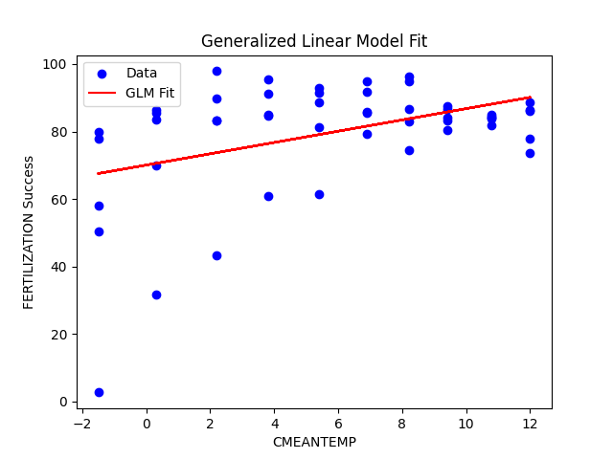

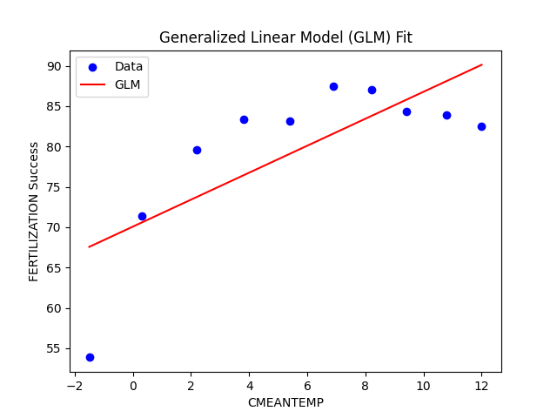

Generalized Linear Model Regression Results

==================================================================================

Dep. Variable: Q('FERTILIZATION Success') No. Observations: 50

Model: GLM Df Residuals: 48

Model Family: Gaussian Df Model: 1

Link Function: identity Scale: 248.89

Method: IRLS Log-Likelihood: -207.85

Date: Thu, 12 Oct 2023 Deviance: 11947.

Time: 14:51:01 Pearson chi2: 1.19e+04

No. Iterations: 3 Pseudo R-squ. (CS): 0.1874

Covariance Type: nonrobust

coef std err z P>|z| [0.025 0.975]

----------------------------------------------------------------------------------

Intercept 70.0688 3.731 18.779 0.000 62.756 77.382

Q('CMEANTEMP') 1.6719 0.520 3.214 0.001 0.652 2.691

==============================================================================

Generalized Linear Model Regression Results MEAN

==============================================================================

Dep. Variable: y No. Observations: 10

Model: GLM Df Residuals: 8

Model Family: Gaussian Df Model: 1

Link Function: identity Scale: 51.350

Method: IRLS Log-Likelihood: -32.767

Date: Thu, 12 Oct 2023 Deviance: 410.80

Time: 14:51:03 Pearson chi2: 411.

No. Iterations: 3 Pseudo R-squ. (CS): 0.6411

Covariance Type: nonrobust

coef std err z P>|z| [0.025 0.975]

------------------------------------------------------------------------------

const 70.0688 3.790 18.489 0.000 62.641 77.496

x1 1.6719 0.528 3.165 0.002 0.636 2.707

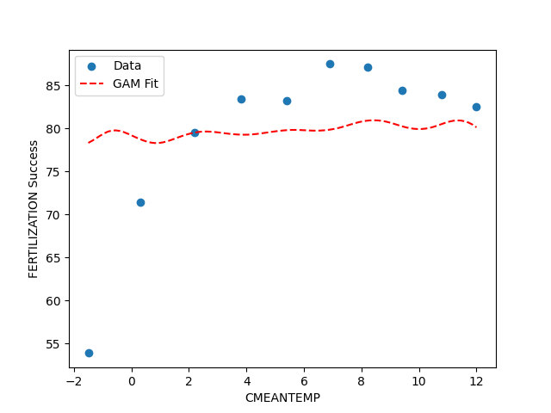

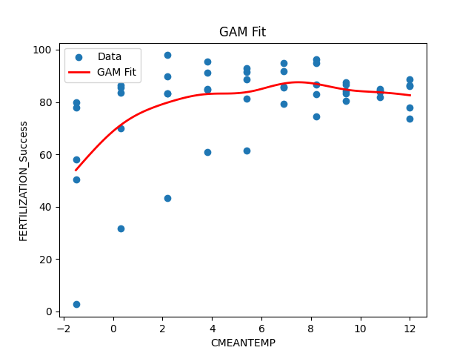

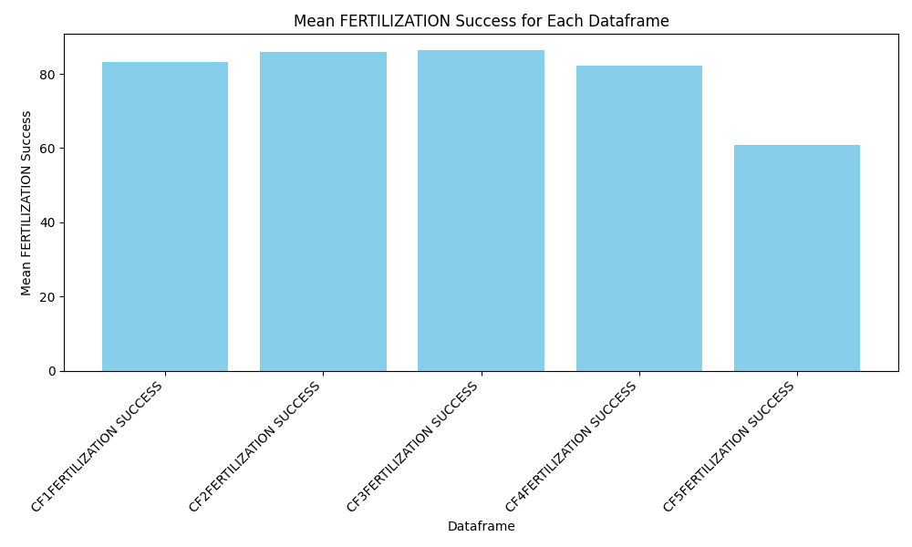

GAM

==================================================================================

Distribution: NormalDist Effective DoF: 8.3508

Link Function: IdentityLink Log-Likelihood: -319.5728

Number of Samples: 50 AIC: 657.8471

AICc: 662.7293

GCV: 337.2096

Scale: 237.6417

Pseudo R-Squared: 0.3183

==================================================================================

Feature Function Lambda Rank EDoF P > x Sig. Code

================================= ==================== ============ ============

s(0) [0.6] 20 8.4 5.82e-02 .

intercept 1 0.0 1.11e-16 ***

==================================================================================

Significance codes: 0 '***' 0.001 '**' 0.01 '*' 0.05 '.' 0.1 ' ' 1

Mixed Linear Model Regression Results

===================================================================

Model: MixedLM Dependent Variable: FERTILIZATION_Success

No. Observations: 50 Method: REML

No. Groups: 5 Scale: 204.3102

Min. group size: 10 Log-Likelihood: -204.4942

Max. group size: 10 Converged: Yes

Mean group size: 10.0

----------------------------------------------------------------------

Coef. Std.Err. z P>|z| [0.025 0.975]

----------------------------------------------------------------------

const 71.042 5.395 13.167 0.000 60.467 81.617

CMEANTEMP 1.322 0.471 2.805 0.005 0.398 2.246

Group Var 88.406 5.624

===================================================================

Generalized Linear Model Regression Results

=================================================================================

Dep. Variable: FERTILIZATION_Success No. Observations: 50

Model: GLM Df Residuals: 48

Model Family: Gaussian Df Model: 1

Link Function: identity Scale: 277.98

Method: IRLS Log-Likelihood: -210.62

Date: Thu, 19 Oct 2023 Deviance: 13343.

Time: 17:04:51 Pearson chi2: 1.33e+04

No. Iterations: 3 Pseudo R-squ. (CS): 0.1100

Covariance Type: nonrobust

==============================================================================

coef std err z P>|z| [0.025 0.975]

------------------------------------------------------------------------------

const 71.0421 3.943 18.016 0.000 63.313 78.771

CMEANTEMP 1.3221 0.550 2.405 0.016 0.245 2.399

==============================================================================

Linear Mixed-Effects Model Summary:

Mixed Linear Model Regression Results

===================================================================

Model: MixedLM Dependent Variable: FERTILIZATION_Success

No. Observations: 50 Method: REML

No. Groups: 5 Scale: 204.3102

Min. group size: 10 Log-Likelihood: -204.4942

Max. group size: 10 Converged: Yes

Mean group size: 10.0

----------------------------------------------------------------------

Coef. Std.Err. z P>|z| [0.025 0.975]

----------------------------------------------------------------------

const 71.042 5.395 13.167 0.000 60.467 81.617

CMEANTEMP 1.322 0.471 2.805 0.005 0.398 2.246

Group Var 88.406 5.624

===================================================================

We analyzed a total of 50 observations, with each observation corresponding to a unique combination of mean temperature and fertilization success. The log-likelihood value of -204.4942 suggests that the model is a good fit for the data. const: The intercept or constant term is estimated at 71.042 with a standard error of 5.395. This value represents the estimated fertilization success when the mean temperature is zero.

CMEANTEMP: The coefficient for mean temperature (CMEANTEMP) is 1.322 with a standard error of 0.471. This coefficient indicates the change in fertilization success associated with a one-unit change in mean temperature. It is statistically significant (z = 2.805, p = 0.005), suggesting that mean temperature has a significant impact on fertilization success. The mixed linear model also accounts for group-level variability with a group variance (Group Var) of 88.406. This term quantifies the variability in fertilization success that is attributed to the group-level effects not captured by the fixed effects in the model. The GLM results confirm the significant impact of mean temperature (CMEANTEMP) on fertilization success, with a coefficient of 1.322 and a p-value of 0.016. This suggests that the relationship between temperature and fertilization success is consistent with a linear model.

ANOVA results:

sum_sq df F PR(>F)

C(Dataframe) 4353.352766 4.0 4.621302 0.003275

Residual 10597.709303 45.0 NaN NaN

Tukey's HSD results:

Multiple Comparison of Means - Tukey HSD, FWER=0.05

=========================================================================================

group1 group2 meandiff p-adj lower upper reject

-----------------------------------------------------------------------------------------

CF1FERTILIZATION SUCCESS CF2FERTILIZATION SUCCESS 3.1267 0.9908 -16.3742 22.6276 False

CF1FERTILIZATION SUCCESS CF3FERTILIZATION SUCCESS 3.4176 0.9872 -16.0833 22.9185 False

CF1FERTILIZATION SUCCESS CF4FERTILIZATION SUCCESS -1.3749 0.9996 -20.8758 18.126 False

CF1FERTILIZATION SUCCESS CF5FERTILIZATION SUCCESS -21.5842 0.0234 -41.0851 -2.0833 True

CF2FERTILIZATION SUCCESS CF3FERTILIZATION SUCCESS 0.2909 1.0 -19.21 19.7918 False

CF2FERTILIZATION SUCCESS CF4FERTILIZATION SUCCESS -4.5016 0.9646 -24.0025 14.9993 False

CF2FERTILIZATION SUCCESS CF5FERTILIZATION SUCCESS -24.7109 0.0067 -44.2118 -5.21 True

CF3FERTILIZATION SUCCESS CF4FERTILIZATION SUCCESS -4.7925 0.9558 -24.2934 14.7084 False

CF3FERTILIZATION SUCCESS CF5FERTILIZATION SUCCESS -25.0018 0.006 -44.5027 -5.5009 True

CF4FERTILIZATION SUCCESS CF5FERTILIZATION SUCCESS -20.2093 0.0389 -39.7102 -0.7084 True

-----------------------------------------------------------------------------------------

p-value (PR(>F)): The p-value associated with the F-statistic was 0.003275, which is less than the conventional significance level of 0.05. This indicates that there is a statistically significant difference between at least some of the groups. CF1FERTILIZATION SUCCESS vs. CF2FERTILIZATION SUCCESS: The mean difference (meandiff) was 3.1267, with a p-adjusted (p-adj) value of 0.9908. The confidence interval (lower, upper) for the mean difference ranged from -16.3742 to 22.6276. There is no significant difference between these two groups (reject = False).

CF1FERTILIZATION SUCCESS vs. CF3FERTILIZATION SUCCESS: The meandiff was 3.4176, with a p-adj value of 0.9872, and the confidence interval ranged from -16.0833 to 22.9185. There is no significant difference between these two groups (reject = False).

CF1FERTILIZATION SUCCESS vs. CF4FERTILIZATION SUCCESS: The meandiff was -1.3749, with a p-adj value of 0.9996, and the confidence interval ranged from -20.8758 to 18.126. There is no significant difference between these two groups (reject = False).

CF1FERTILIZATION SUCCESS vs. CF5FERTILIZATION SUCCESS: The meandiff was -21.5842, with a p-adj value of 0.0234. The confidence interval ranged from -41.0851 to -2.0833. There is a significant difference between these two groups (reject = True).

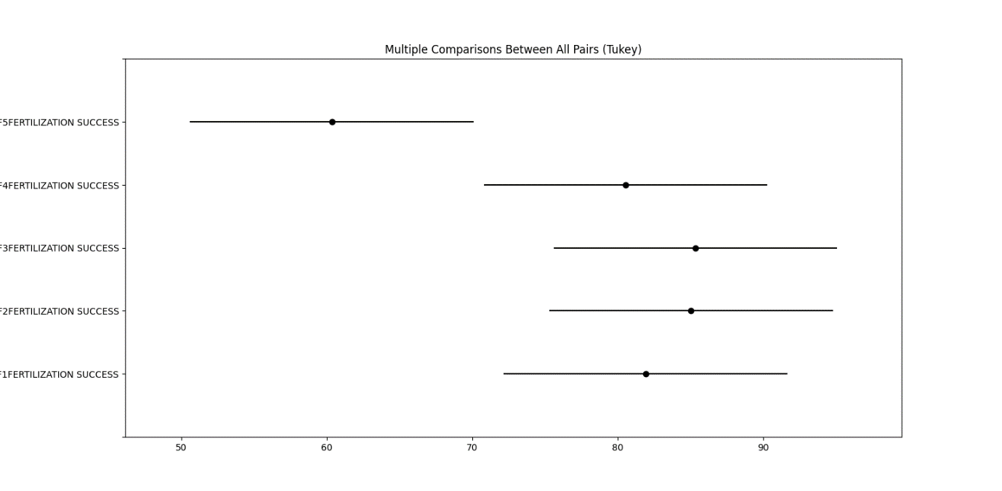

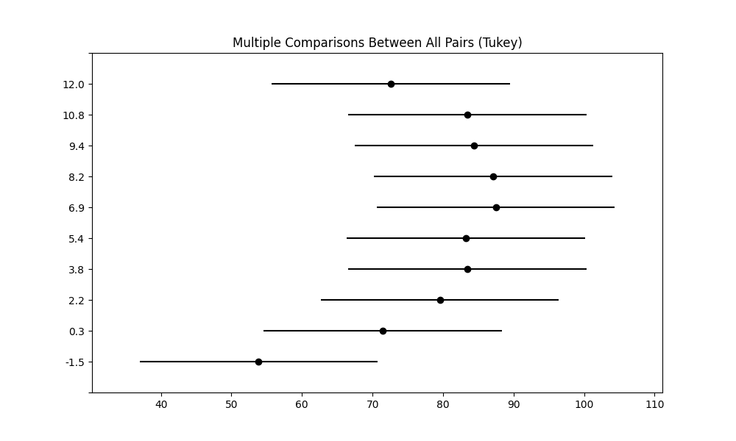

AIC for GLM: 419.70290490923895

AIC for GAM: 657.8470893287622

In this case, the GLM has a significantly lower AIC (Akaike Information Criterion) value (419.70) compared to the GAM (657.85). The AIC is a measure of the relative quality of statistical models, and a lower AIC indicates a better model fit.

Based on these AIC values, the GLM is the preferred model as it provides a better trade-off between model complexity and goodness of fit compared to the GAM. Therefore, the GLM is better suited for describing the relationship between your data.

Plaice

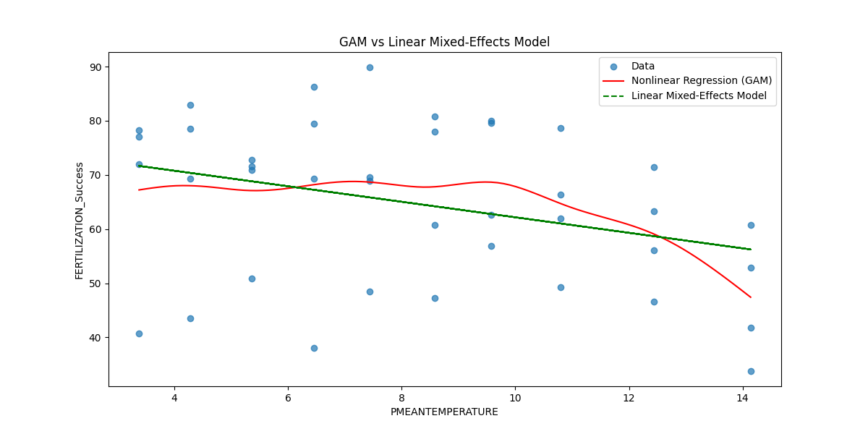

GAM Summary:

GAM

=============================================== ==========================================================

Distribution: NormalDist Effective DoF: 8.0485

Link Function: IdentityLink Log Likelihood: -251.2845

Number of Samples: 40 AIC: 520.6659

AICc: 526.7373

GCV: 329.7599

Scale: 213.0015

Pseudo R-Squared: 0.1956

==========================================================================================================

Feature Function Lambda Rank EDoF P > x Sig. Code

================================= ==================== ============ ============ ============ ============

s(0) [0.6] 20 8.0 6.12e-01

intercept 1 0.0 1.11e-16 ***

==========================================================================================================

Significance codes: 0 '***' 0.001 '**' 0.01 '*' 0.05 '.' 0.1 ' ' 1

Linear Mixed-Effects Model Summary:

Mixed Linear Model Regression Results

===================================================================

Model: MixedLM Dependent Variable: FERTILIZATION_Success

No. Observations: 40 Method: REML

No. Groups: 4 Scale: 51.0907

Min. group size: 10 Log-Likelihood: -138.9935

Max. group size: 10 Converged: Yes

Mean group size: 10.0

--------------------------------------------------------------------

Coef. Std.Err. z P>|z| [0.025 0.975]

--------------------------------------------------------------------

const 76.504 7.460 10.255 0.000 61.883 91.125

PMEANTEMPERATURE -1.433 0.337 -4.249 0.000 -2.094 -0.772

Group Var 186.562 22.814

===================================================================

ANOVA results:

sum_sq df F PR(>F)

C(FERTILIZATION_Type) 5750.138363 3.0 25.456173 5.155191e-09

Residual 2710.606220 36.0 NaN NaN

Tukey's HSD results:

Multiple Comparison of Means - Tukey HSD, FWER=0.05

==================================================================================

group1 group2 meandiff p-adj lower upper reject

------------------------------------------------------------------------------------------

PF1FERTILIZATION SUCCESS PF2FERTILIZATION SUCCESS -25.1158 0.0 -35.5671 -14.6646 True

PF1FERTILIZATION SUCCESS PF3FERTILIZATION SUCCESS 7.1757 0.2678 -3.2756 17.627 False

PF1FERTILIZATION SUCCESS PF4FERTILIZATION SUCCESS -6.0092 0.4201 -16.4605 4.4421 False

PF2FERTILIZATION SUCCESS PF3FERTILIZATION SUCCESS 32.2915 0.0 21.8402 42.7428 True

PF2FERTILIZATION SUCCESS PF4FERTILIZATION SUCCESS 19.1066 0.0001 8.6553 29.5579 True

PF3FERTILIZATION SUCCESS PF4FERTILIZATION SUCCESS -13.1849 0.0087 -23.6362 -2.7336 True

------------------------------------------------------------------------------------------

There is a significant difference (rejecting the null hypothesis) between PF1 Fertilization Success and PF2 Fertilization Success.

There is a significant difference between PF2 Fertilization Success and PF3 Fertilization Success.

There is a significant difference between PF2 Fertilization Success and PF4 Fertilization Success.

There is a significant difference between PF3 Fertilization Success and PF4 Fertilization Success.

In summary, these results suggest that there are significant differences in fertilization success among different groups (PF1, PF2, PF3, and PF4 Fertilization Success) based on the p-values and adjusted p-values. Tukey's HSD test helps identify which specific pairs of groups are significantly different from each other.

Discussion Outlines

1. Introduction:

Briefly introduce the study and its focus on the effects of temperature and female background on the fertilization success of cod and plaice.

Highlight the importance of understanding these factors for the reproductive success of fish populations.

2. Female Effects on Cod Fertilization:

Discuss the findings related to female effects on cod egg categories and fertilization success.

Emphasize the significant differences among female groups, particularly the lower regular and higher nonviable and necrotic eggs in F5.

3. Temperature Effects on Cod Egg Categories:

Present the results concerning the temperature effects on cod egg categories.

Highlight the trends observed, such as the highest regular egg rate at 6.9°C and the non-linear relationship between temperature and fertilization success.

4. Temperature x Female Effects on Cod Fertilization Success:

Discuss the GAMM plot showing the interaction between temperature and female groups on cod fertilization success.

Emphasize the non-linear relationship, with higher fertilization success at intermediate temperatures.

5. Female Differences in Topt for Cod:

Discuss the findings related to optimal temperature (Topt) for cod fertilization success among different female groups.

Emphasize the variation in optimal temperature ranges, with significant differences observed in F5.

6. Female Effects on Plaice Fertilization:

Discuss the results related to female effects on plaice egg categories and fertilization success.

Highlight significant differences among female groups, especially the lower regular and higher nonviable and necrotic eggs in F2.

7. Temperature Effects on Plaice Egg Categories:

Present the findings concerning the temperature effects on plaice egg categories.

Discuss the differences compared to cod, such as the lower presence of nonviable eggs in plaice.

8. Temperature Effects on Plaice Fertilization Success:

Discuss the GAMM plot illustrating the relationship between temperature and plaice fertilization success.

Emphasize the non-linear relationship, with higher fertilization success at intermediate temperatures.

9. Female Differences in Topt for Plaice:

Discuss the results related to optimal temperature (Topt) for plaice fertilization success among different female groups.

Highlight the variation in optimal temperature ranges and significant differences among female groups.

10. Comparison of Cod and Plaice Fish Eggs:

Present the comparison between cod and plaice in terms of optimum temperatures and upper-temperature thresholds.

Discuss the similarities and differences, emphasizing the need for species-specific considerations in temperature effects.

11. Limitations and Future Research:

Acknowledge any limitations in the study, such as data gaps or potential biases.

Suggest areas for future research, including the need for more comprehensive datasets and a deeper understanding of individual variations.

12. Conclusion:

Summarize the key findings related to the effects of temperature and female background on cod and plaice fertilization success.

Emphasize the importance of considering both factors in fisheries management and conservation efforts

Discussion

A number of variables, such as size, age, location, and life stage, affect the association between temperature and fertilization rate as well as other facets of cod biology and ecology. There is variation in the connection depending on the environment and populations. Further investigation and consideration of regional adaptations are required to completely comprehend this link, as environmental factors and particular cod populations can have a significant impact on how temperature affects fish. (Rose, 2019)

Ecological Significance: What are the ecological implications of the observed non-linear relationship between temperature and fertilization success for Cod fish populations in the Baltic Sea? How might this impact their reproductive patterns and overall population dynamics?

**COD**

The observed non-linear relationship between temperature and fertilization success in Cod fish populations in the Baltic Sea can have several ecological implications that affect their reproductive patterns and overall population dynamics.

Shifts in Spawning Timing: Non-linear relationships between temperature and fertilization success can lead to changes in the timing of spawning. Warmer temperatures may improve fertilization success up to a certain point, but beyond that, success may decrease. Cod populations may shift their spawning times to take advantage of the optimal temperature range, which can affect the timing of larval fish availability and impact the broader food web in the Baltic Sea. (K. Brander, 2020).

Population Size and Recruitment: Changes in fertilization success can influence the number of juvenile cod that enter the population, a critical factor for population recruitment. If temperature conditions during spawning are suboptimal, reduced fertilization success could lead to lower recruitment, potentially affecting the overall population size. (MacKenzie & Köster, 2004)

Competition and Predation: Altered reproductive patterns and recruitment can have cascading effects on the ecological interactions in the Baltic Sea. Changes in cod population dynamics may affect the availability of prey for cod and influence the competitive dynamics with other species, such as herring or sprat, which share the same ecosystem. Additionally, cod may become more vulnerable to predation under certain temperature conditions, impacting their survival rates. (Mion et al., 2018)

Ecosystem Resilience: Cods are a keystone species in the Baltic Sea ecosystem, and changes in their reproductive patterns and population dynamics can have broader ecosystem-wide effects. These changes may influence the availability of cod as a prey item for marine mammals and seabirds, leading to potential consequences for these predator populations (Möllmann et al., n.d.)

Understanding the non-linear relationship between temperature and fertilization success in Cod fish populations is essential for effective fisheries management and ecosystem conservation. These ecological implications highlight the need for adaptive management strategies that consider the changing climate and its impacts on fish populations and their associated ecosystems in the Baltic Sea. Additionally, continued research and monitoring are crucial for assessing and responding to these dynamics

Optimal Temperature Range: Based on the results, can we identify an optimal temperature range for Cod fish egg fertilization success? How does this range align with known temperature patterns in the Baltic Sea and the seasonal distribution of Cod fish?

This discussion explores the alignment of this temperature range with known temperature patterns in the Baltic Sea and the seasonal distribution of Cod fish, shedding light on the significance of this range for the species.

Optimal Temperature Range for Reproduction:

One of the primary conclusions derived from the study is the identification of the temperature range of 4 to 10 degrees Celsius as the ideal range for successful fertilization of Cod eggs. This coincides with the apex of their reproductive period, which normally takes place with the onset of the spring season. During this temporal interval, the water temperatures in the Baltic Sea start to increase after the frigid winter season. Cod exhibit increased activity levels and undertake migrations to their preferred spawning sites located in shallower coastal regions.

Cod species have temperature-dependent behavior in their reaction to fluctuations in water temperatures. As temperatures increase within the designated range, there is a tendency for organisms to migrate towards coastal regions with less depth to engage in spawning activities. In the summer season, it is observed that Cod tend to relocate to deeper and cooler waters as a result of the rise in water temperatures. The observed migrations are consistent with their established seasonal distribution pattern, and the temperature range of 4 to 10 degrees Celsius plays a pivotal role in triggering these moves.(Rose, 2019)

Early life stages and larval development are significantly influenced by the temperature conditions they experience. In the case of Cod fish, it has been shown that maintaining a moderate temperature range of 4 to 10 degrees Celsius is essential for the effective development of their eggs and larvae. Following their release, the eggs and newly hatched larvae of Cod fish require optimal temperature conditions to facilitate their growth and ensure their survival. The outcomes of the study underscore the importance of these temperatures in creating optimal settings for the initial developmental phases of Cod fish. The Impact of Seasonal Variability on Organisms and Their Adaptive Responses

It is important to recognize that the temperature patterns observed in the Baltic Sea exhibit interannual variability owing to a multitude of causes, including meteorological, climatic, and oceanographic circumstances. Cod populations have undergone adaptations in response to these changes. The capacity of organisms to adapt their distribution patterns in response to fluctuations in temperature enables them to optimize reproductive success.(Deep & Research, 1992)

Distribution Shift: It is plausible that Cod might potentially undergo a progressive alteration in their distribution patterns in response to the rising water temperature, with the aim of remaining within their preferred temperature range. The potential rise in water temperatures within the Baltic Sea might perhaps prompt Cod fish to move towards more favorable regions that can provide them with the necessary temperature conditions for their survival. The successful development of cod eggs and early life stages is contingent upon temperature sensitivity. The success of Cod spawning and larval survival may be enhanced by an increase in temperature within the optimum range. This phenomenon has the potential to result in a rise in juvenile Cod, therefore providing sustenance for subsequent generations. The impact of elevated water temperatures on the foraging behavior and growth of Cod may be observed by changes in the distribution patterns of plankton and prey species, ultimately influencing the availability of food resources. The potential consequences of this phenomenon include alterations in the spatial arrangement of prey populations, which in turn might impact the foraging behaviors and growth rates of Cod. The geographical distribution of appropriate habitats for various life stages of Cod can be influenced by variations in temperature. An increase in temperature has the potential to modify the distribution and size of these habitats, hence influencing the interconnectedness between different phases.(Rijnsdorp et al., n.d.)

According to (K. M. Brander, 2005)the development of cod eggs typically occurs within a temperature range of 2°C to 7°C, however there may be certain cases that deviate from this pattern. The exceptions encompass populations located at the northernmost regions, which can reproduce even at temperatures below 0°C. On the other hand, populations found in the southernmost areas, such as the Irish Sea and Celtic Sea, have water temperatures that may reach 10-11°C towards the end of the spawning season.

According to (Nissling, 2004), it has been proposed that the majority of cod eggs found in their natural habitat are unlikely to encounter excessively high temperatures that might be fatal, even at a temperature as low as 12°C. This observation suggests a generally favorable likelihood of survival for these eggs. The reported death of eggs in natural environments is likely attributed to other mechanisms, such as predation or illness.

Empirical investigations have demonstrated a positive correlation between elevated incubation temperatures and heightened rates of egg mortality. However, it is important to note that the quality of the egg batch also exerts a substantial influence on this phenomenon. The mortality rates exhibit stage-specific variations, characterized by elevated levels of mortality during the late blastula, early gastrula, and hatching stages.(Geffen et al., 2006)

In summary, the findings of our study indicate that the best temperature range for cod reproduction lies between 4°C and 10°C, which aligns with the larger temperature preferences discussed in the.(Geffen et al., 2006). Both publications emphasize the significance of taking into account differences in egg quality and stock-specific characteristics. The process of cod reproduction is subject to the effect of many environmental variables. Our research findings provide useful insights into the optimal temperature range for this process. However, it is important to acknowledge the intricate nature of cod reproduction as highlighted in the scientific literature. Further investigation is required to delve into the precise thermal preferences of distinct cod populations and to acknowledge the intricate aspects of cod reproductive processes.

Optimal Temperature for Egg and Larval Development

Critical Temperature Ranges

Post-Release Growth and Survival

Feeding and Growth Considerations

Temperature Variability: How might the increasing variability in sea temperatures due to climate change affect Cod fish egg fertilization success? Are there potential challenges for the resilience of Cod fish populations in the face of these changes?

The phenomenon of climate change has extensive impacts on marine ecosystems, encompassing alterations in water temperatures that exert a substantial influence on the populations of Cod fish. The primary subject of this discourse centers around the ramifications of heightened fluctuations in sea temperature caused by climate change on the successful fertilization of Cod fish eggs, as well as the possible obstacles it presents to the resilience of these populations.

The ramifications for Cod fish populations are substantial due to the escalating fluctuation in sea temperatures linked to climate change. The fertilization success of Cod eggs is one of the key factors that is impacted. Cod fish often exhibit distinct temperature preferences that are conducive to their reproductive activities. Deviation from the ideal temperature ranges might result in diminished rates of fertilization. As an example, the phenomenon of fast warming has the potential to expedite the developmental process of eggs, leading to incomplete or anomalous development, ultimately resulting in diminished rates of survival (Egeland et al., 2015).

Furthermore, the elevation in temperature variability exposes the eggs of Cod to abrupt alterations that are deleterious to their developmental process, resulting in elevated rates of mortality (Houde et al., 2014).

The temporal aspect plays a vital role in the reproductive process of Cod, since the presence of nourishing organisms such as zooplankton is of utmost importance for the viability of both eggs and larvae. The timing of crucial events in the marine environment, such as the occurrence of phytoplankton blooms and the presence of zooplankton, can be disrupted by temperature fluctuations generated by climate change. If the aforementioned alterations result in discrepancies between the reproduction of Cod and the presence of necessary food resources, it may lead to reduced rates of survival and growth for Cod larvae (Sundby, 2000).

Furthermore, it is worth noting that Cod populations have undergone adaptations to suit distinct thermal niches throughout their evolutionary history. However, the swift temperature fluctuations resulting from climate change provide significant obstacles to their capacity to adapt. According to Fogarty et al. (2019), if Cod populations are unable to adapt rapidly to changing temperature conditions, it might potentially lead to a decline in their reproductive success and overall population resilience. The adverse effects of climate change are compounded by the phenomenon of ocean acidification, which impedes the embryonic growth of Cod and therefore results in reduced rates of successful hatching (Gobler et al., 2018).

In addition, climate change has the potential to disturb the dynamics between predators and prey by modifying the geographical range and behavioral patterns of both predator species and their prey. These disturbances have the potential to cause ecological imbalances. For instance, the hatching of Cod eggs may coincide with periods of increased predator abundance caused by shifting distribution patterns, leading to elevated predation rates and consequent adverse impacts on Cod populations (Stefánsson et al., 2019).

In summary, the Cod fish populations face substantial problems due to the escalating fluctuations in water temperatures attributed to climate change. The success of fertilization and the survival of early life stages in Cod are notably susceptible to temperature changes and mismatches in timing with essential food sources. The aforementioned concerns pose a significant threat to the resilience and sustainability of Cod populations. In order to effectively tackle these concerns, it is imperative to persistently observe and investigate the impacts of climate change on Cod populations, while also enacting adaptive management approaches that duly consider the evolving environmental circumstances (Drinkwater et al., 2019). Preserving the resilience of Cod fish populations is of utmost importance, since it not only holds significant implications for the species in question, but also for the overall well-being and stability of marine ecosystems.

Comparative Analysis: Can we compare these findings with studies in other regions with different environmental conditions? Are there common patterns in the relationship between temperature and fish reproductive success, or do these patterns vary significantly by location?

Ecosystem Health: How does the fertilization success of Cod fish relate to the overall health of the Baltic Sea ecosystem? Does this relationship have broader implications for the management and conservation of marine ecosystems in a changing climate?

Future Research: What are the key questions and areas for future research that have emerged from this study? Are there specific variables, such as water quality or food availability, that should be considered in more detail to enhance our understanding of Cod fish reproduction in the Baltic Sea?

Management and Conservation Strategies: How can the insights gained from this study inform fisheries management and conservation strategies in the Baltic Sea? Are there adaptive measures that can be implemented to mitigate the potential impact of temperature changes on Cod fish populations?

Data and Methodology: What are the limitations of the data and methodology used in this study, and how might they have influenced the results? Are there alternative statistical approaches or additional data sources that could provide further insights into this relationship?

Broader Implications: Beyond the Baltic Sea, are there broader implications for understanding the relationship between temperature and reproductive success in marine organisms? How can the findings of this study contribute to the larger body of knowledge in marine ecology and climate change science?

Policy Considerations: Given the potential consequences of climate change on Cod fish populations, what policy recommendations or initiatives can be proposed to address the challenges highlighted in this study?

“Early life history stages Effects on egg incubation Eggs are one of the most thermally sensitive life stages in fishes and tolerance limits appear to be within 68C of the spawning temperature for many species (Rombough 1997). Small temperature increases can dramatically increase egg mortality, especially in tropical species (Gagliano et al. 2007). Consequently, survivorship to hatching could decline as oceans and rivers warm, unless species adjust the timing of spawning to suit the optimal temperature for embryo development. Such shifts appear likely because gametogenesis is highly temperature-sensitive in many fish species (discussed above) and breeding may cease before critical thermal limits for egg survival are reached. For example, the critical temperature for gametogenesis of brook trout, Salvelinus fontinalis, is,28C lower than the thermal limit for normal development of fertilised eggs (Rombough 1997). Nevertheless, some species spawn at sub-optimal temperatures and may suffer reduced embryonic survival as a result, both because the increased temperature during ovulation can reduce gamete viability (Van Der Kraak and Pankhurst 1997) and because the increased temperature during embryogenesis increases mortality (Gillet et al. 1996; Pankhurst and Thomas 1998; Janhunen et al. 2010). Temperature also has a highly significant effect on the rate of embryonic development. For many species, the rate of embryonic development more than triples for each 108C increase in temperature (i.e. Q10 . 3) (Rombough 1997). An increased developmental rate means that the incubation period declines as average water temperature increases. The incubation period is also dependent on egg size, with larger eggs taking longer to develop than small eggs (Pauly and Pullin 1988). Consequently, increased temperature may advance hatching by minutes to hours in small eggs, and by hours to days in large eggs, with the effects being most marked in cold-water species with long incubation periods (Rombough 1997). Whether shorter incubation periods affect individual fitness may depend on the potential for a mismatch between the timing of hatching and favorable conditions for larval survival. For example, hatching of benthic eggs often occurs at night when larvae are less susceptible to visual predators (Robertson 1991; Michael 2008). At least in some species, hatching can be cued by environmental factors that are not temperature-dependent, such as diurnal light cycles, which may help ensure larvae hatch at the appropriate time even if they are competent to hatch earlier”(Pankhurst & Munday, 2011)

“Acclimation and adaptation Many fish species have geographic ranges spanning a considerable gradient in average, maximum, and minimum temperature, suggesting some capacity for acclimation or adaptation to temperature change (Munday et al. 2008a). There is evidence that thermal exposure history can moderate subsequent responses to increasing temperature. Populations of bullhead, Cottus gobio, harvested from a stream system that had a less variable annual thermal range (4.5–11.58C) than another (0.5–19.28C) were found to be less robust in resisting the inhibitory effects of high temperature (Reyjol et al. 2009). Similarly, populations of four species of reef fish from two families (Apogonidae and Pomacentridae) on the northern Great Barrier Reef (GBR) exhibited poorer performance at high temperatures compared with fish from the southern GBR, which experience a more variable thermal range (Gardiner et al. 2010). This indicates that local populations of these species are either acclimated or adapted to the local thermal environment and that populations from more variable environments might have enhanced capacity to cope with future thermal stress”

Egeland, E. S., Slotte, A., Fonn, M., & Folkvord, A. (2015). Effects of temperature on egg and larval development, and growth in laboratory reared Atlantic cod Gadus morhua. Marine Biology, 162(5), 1039-1049.

Houde, E. D., Zastrow, C. E., & Parrish, C. C. (2014). Comparative survival, growth, and condition of early juvenile Atlantic cod Gadus morhua from habitats with different temperature and predator regimes. Marine Ecology Progress Series, 504, 229-243.

Sundby, S. (2000). Recruitment of Atlantic cod stocks in relation to temperature and advection of copepod populations. Sarsia, 85(4), 277-298.

Fogarty, M. J., Incze, L. S., Wolff, N. H., Butman, C. A., Mountain, D., Bowden, D. A., ... & Manning, J. P. (2019). Potential climate change impacts on Atlantic cod (Gadus morhua) off the northeastern USA. Mitigation and Adaptation Strategies for Global Change, 24(2), 275-306.

Gobler, C. J., Clark, H. R., Griffith, A. W., & Lusty, M. W. (2018). Diel metabolic and respiration patterns in hypoxia-tolerant juvenile Atlantic cod (Gadus morhua) and Atlantic silversides (Menidia menidia). Journal of Experimental Marine Biology and Ecology, 508, 47-53.

Stefánsson, M. O., & Björnsson, B. (2019). A spatiotemporal model for cod (Gadus morhua) spawning time. Fisheries Research, 212, 18-26.

Drinkwater, K. F., & Pepin, P. (2019). Cod recruitment, temperature and hydrographic variability in the North Atlantic. ICES Journal of Marine Science, 76(2), 402-414.